INTERNET OF THINGS-GROUP 4

PHASE 1

SMART PARKING

STUDENT NAME : R.AKILRAJ

REGISTER NUMBER :822621106005

NM ID :au822621106005

COLLEGE CODE :8226

COLLEGE NAME : ARIFA INSTITUTE OF TECHNOLOGY,NAGAPATTINAM

EMAIL ID :akilrajakilraj0@gmail.com

ABSTRACT

The project entitled SMART PARKING SYSTEM using Iot , the major motivation of this project is to reduce the traffic congestion in roads, multi-storeyed buildings and malls due to unavailability of parking spaces .The project displays the nearest empty slot if present with respect to user location. Our project aims to make efficient use of parking spaces. We track vacant slots in the parking space and assign that to the user. Smart parking system as described above can lead to an error-free ,reliable, secure and fast management system. In recent times the concept of smart cities have gained great popularity. Thanks to the evolution of the Internet of things the idea of smart city now seems to be achievable. Consistent efforts are being made in the field of IoT in order to maximize the productivity and reliability of urban infrastructure. Problems such as, traffic congestion, limited car parking facilities and road safety are being addressed by IoT. The proposed Smart Parking system consists of an on-site deployment of an IoT module that is used to monitor and signalize the state of availability of each single parking space. A mobile application is also provided that allows an end user to check the availability of parking space and book a parking slot accordingly. The paper also describes a highlevel view of the system architecture. Towards the end, the paper discusses the working of the system in form of a use case that proves the correctness of the proposed model.

# INTRODUCTION

The project entitled smart parking system is to manage all the parking facilities to an user. The recent growth in economy and due to the availability of low price cars in the market, an every average middle-class individual can afford a car, which is good thing, however the consequences of heavy traffic jams, pollution, less availability of roads and spot to drive the motor car. One of the important concerns, which is to be taken in accounting, is the problem of parking those vehicles .Though, if there is space for parking the vehicle but so much time is squandered in finding that exact parking slot resulting in more fuel intake and not also environment friendly. It will be a great deal if in some way we find out that the parking itself can provide the precise vacant position of a parking slot then it'll be helpful not limited to the drivers also for the environment . Initially when the user is about to enter the location the LCD displays the number of empty and filled spots and when the user is with its vehicle near to the parking detect sensor ,he/she would be thrown with a notification on their mobile app of the parking slot number ,where they should park there vehicle.

## Relevance of the project

The main important benefit of a smart parking system is its advanced technology. It follows the latest technologies and concepts to assure profitable outcomes . The design and implementation of smart parking is very easy to supervise and manage. This system can be easily handled by the staff members because of its well organized structure.

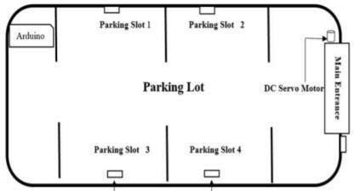

block diagram of smart parking system

**Problem Statement**

In recent research in metropolitan cities the parking management problem can be viewed from various angles such as high vehicle density on roads. This results in annoying issues for the drivers to park their vehicles as it is very difficult to find a parking slot.

The drivers usually waste time and effort in finding parking space and end up parking their vehicles finding a space on the street which further leads to space congestion. In worst case, people fail to find any parking space especially during peak hours and festive season.

## Objective

Smart Parking involves the use of low cost sensors, real-time data and applications that allow users to monitor available and unavailable parking spots. The goal is to automate and decrease time spent manually searching for the optimal parking floor, spot and even lot. Some solutions will encompass a complete suite of services such as online payments, parking time notifications and even car searching functionalities for very large lots. A parking solution can greatly benefit both the user and the lot owner.

**Optimized parking** – Users find the best spot available, saving time, resources and effort. The parking lot fills up efficiently and space can be utilized properly by commercial and corporate entities.

**Reduced traffic** – Traffic flow increases as fewer cars are required to drive around in search of an open parking space.

**Reduced pollution** – Searching for parking burns around one million barrels of oil a day. An optimal parking solution will significantly decrease driving time, thus lowering the amount of daily vehicle emissions and ultimately reducing the global environmental footprint.

**Increased Safety** – Parking lot employees and security guards contain real-time lot data that can help prevent parking violations and suspicious activity. License plate recognition cameras can gather pertinent footage. Also, decreased spot-searching traffic on the streets can reduce accidents caused by the distraction of searching for parking.

**Decreased Management Costs** – More automation and less manual activity saves on labor cost and resource exhaustion.

**Enhanced User Experience** – A smart parking solution will integrate the entire user experience into a unified action. Driver’s payment, spot identification, location search and time notifications all seamlessly become part of the destination arrival process.

## Scope of the project

At present some countries have portals which users can gain information about parking areas via the internet. This system can give users the information about parking space, but it won’t be able to give which parking slot is vacant and occupied. Hence, such a system cannot smartly handle the issue. Car lifts along with an automated robotic system, which automatically takes the car to a particular parking spot as soon as the car enters on a platform. This system cannot be installed by medium scale shopping malls, movie theatres as it can cost them a huge amount. At many public places, the system only shows the availability but it cannot show the exact slot and path to the slot available. Hence, there is the need to smartly find the path to the vacant spot.

## Methodology

In this project we are using NodeMCU, IR sensors, and servo motors. One IR sensor is used at entry and exit gate to detect the car while two IR sensors are used to detect the parking slot availability. Servo motors are used to open and close the gates according to the sensor value. NodeMCU is an open source IoT platform .It includes firmware which runs on the ESP8266 Wi-Fi SoC from Espressif Systems, and hardware, which is based on the ESP-12 module. The term “NodeMCU” by default refers to the firmware rather than the dev kits. The firmware uses the Lua scripting language. The ESP8266 is a low-costWi-Fi enabled microchip with full TCP/IP stack and microcontroller capability. NodeMCU includes CPU core, faster Wi-Fi, more GPIOs, and supports Bluetooth 4.2, and low power Bluetooth. The ESP8266 is a low-costWiFi enabled microchip with full TCP/IP stack and microcontroller capability. NodeMCU includes CPU core, faster Wi-Fi, more GPIOs, and supports Bluetooth 4.2, and low power Bluetooth. As soon as the IR sensors get the presence of a car in front of the entrance, it will send signal to the NodeMCU to check if there is an empty slot inside the parking lot. When NodeMCU acknowledges that there is an empty slot or more then it will send a signal to the dc servo motor which will open the main entrance. On the other hand if an NodeMCU encounters no empty slots at the time of a car trying to make an entrance, the gate will just not open. In addition, there will be a website linked with the NodeMCU board to show the number of parking.

The idea behind our methodology is very simple , usually users spend most of their time in looking for an empty slot where they can park their vehicle which increases fuel consumption and time wastage. We came-up with a new method where we provide the user an empty slot number where he can park his vehicle without wasting his time for finding one . Similarly we try to display the start time and end time so that the user can know for what amount of time he has parked his vehicle.

# LITERATURE SURVEY

## [1] Developing a Smart Parking Management System Using the Internet of Things

Searching for parking wastes significant amounts of time and effort and leads to substantial financial costs. This is particularly the case for people who are always pressured to be on time. Smart cities employ all kinds of modern technologies to manage and enhance resources effectively. Urban parking facilities are one of the essential assets that must be managed. We developed a smart parking management system (SPMS) as a modern solution to manage parking and save users time, effort and cost. In the context of today’s modern life, it has become necessary to improve search methods for available parking and minimize the congestion that occurs at the parking entrance. Searching or booking available parking online earlier is a better substitute than searching at a parking lot where there is a possibility of not being able to find parking. Our smart parking management system was developed to:

* Manage parking and solve problems efficiently using technology
* Apply technical solutions to improve the smart cities concept

The proposed system uses a variety of technologies that help manage parking. It provides essential services for users, including searching for parking, reservations and payment. It is extended to cover more advanced services such as receiving notifications, statistics and monitoring the parking state. The system is connected to sensors to detect occupancy and an automatic number plate recognition (ANPR) camera to control access. The remainder of the paper is organized as follows.

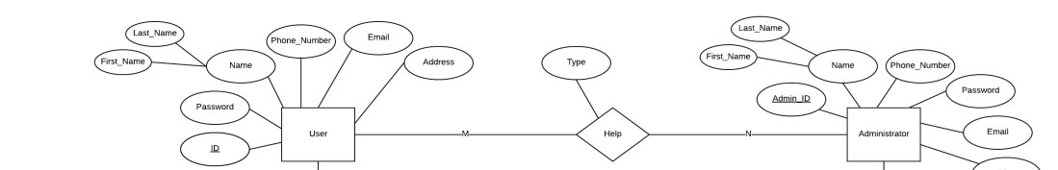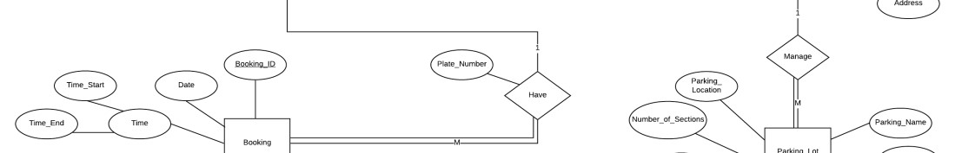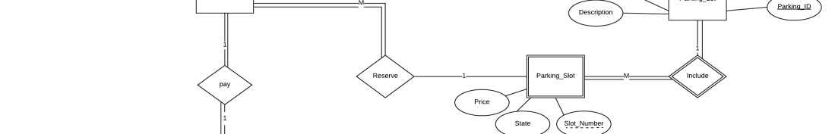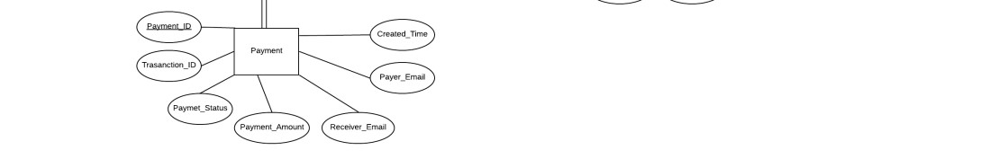

Entity Relationship Diagram of Smart Parking System

## [2] An IoT-based E-Parking System for Smart Cities

The huge proliferation in the number of vehicles on the road along with mismanagement of the available parking space has created parking related problems as well as increased the traffic congestion in urban areas. Thus, it is required to develop an automated smart parking management system that would not only help a driver to locate a suitable parking space for his/her vehicle, but also it would reduce fuel consumption as well as air pollution. It has been found that a drivers search for a suitable parking facility takes almost 15 minutes which increases the fuel consumption by the vehicle, traffic congestion and air pollution. A significant amount of research works exist in the area of design and development of smart parking system. Various features of smart parking system are listed below.

* Inquiry on availability of parking space and reservation of parking lot
* Real-time parking navigation and route guidance
* Vehicle occupancy detection and management of parking lots .

Most of the smart parking systems (SPS) proposed in literature over the past few years provides solution to the design of parking availability information system, parking reservation system, occupancy detection and management of parking lot, real-time navigation within the parking facility etc. However, very few works have paid attention to the real time detection of improper parking and automatic collection of parking charges. Thus, this paper presents an internet-of thing (IoT) based E-parking system that employs an integrated component called parking meter (PM) to address the following issues.

* Real-time detection of improper parking
* Estimation of each vehicles duration of parking lot usage
* Automatic collection of parking charges

The E-parking system proposed in this paper also provides city-wide smart parking management solution via providing parking facility availability information and parking lot reservation system and it is named as parking meter (PM) based E-parking (PM-EP).

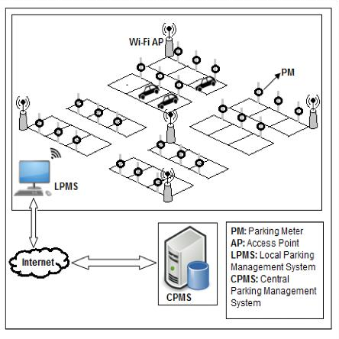

Fig 2.2 Network Architecture of proposed System

## [3] Smart Parking based System for smarter cities

India is getting motorized i.e. the rate of private vehicles is more as compared to public transports. As the rate of people owning their vehicles increases ,the need of parking slots to park vehicles also increases. But currently the scenario is that there are not sufficient parking slots available or there is also possibility that people are not now aware about the legal parking slots available in their locality. This situation leads to the unnecessary crowding of vehicles on the road and also results in inconveniency of people walking on the road. To overcome above problems, We are proposing the solution in the form of a multilingual android application which will be helpful for the people to find their parking slots digitally. By digitally we mean that this particular system will assign the parking slot based on the current location of the user and the parking slot which the user wants according to his/her ease. Ease in terms of finding the exact slot. The payments can be done digitally or through vending machines. The end user can register and login with his/her account which will help the system to find the location and displaying the nearest parking area and nearest parking slot ,whether it is available or not. If not then it will direct user to the next nearest slot and so on.

The existing system comprises of both traditional and application based approach for parking. If we talk about the traditional approach it utilizes manual method of parking i.e user has to find the spot for parking by traveling to far distances and paying extra money. An application based approach consist of the applications which provides the parking slots for the particular locality for example .The application named ‘Parking Panda ’ provides the parking slots to the areas like stadium, sports leagues etc.

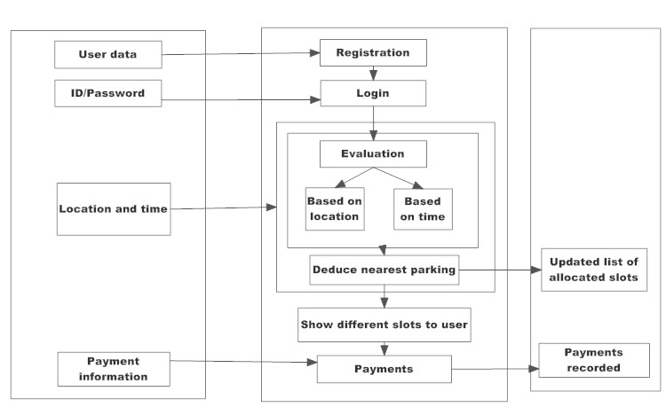

Fig 2.3 Block Diagram of parking system

## [4] SMART PARKING SYSTEM TO REDUCE TRAFFIC CONGESTION

Transportation is the key-success for any of the country. Now a day, many people have options to use their own vehicle for travelling. This will surely increase the demand in trading but one of the problems created by road traffic is "parking". To park all these vehicles in the major metro cities is quite tedious and difficult task and it became problematic to park vehicles. Lot of research and development is being done all over the world to implement better and smarter parking management mechanisms. The current smart parking systems or Wireless Sensors Network Parking requires the combination of wireless sensor networks module, Embedded web-server, Central WebServer. Sensor networks make use of Infrared (IR) Sensor nodes to check the parking slot state and send this information to embedded web-server. It thereby displays the information on a LED screen with which the user can check for empty vehicle slots. These systems not guide the users to reach to the parking lot. If the slot is not available at that time than drivers will start searching for another parking zone so that this process is time consuming and will increase the traffic congestion.

This paper proposes a Reservation-based Smart Parking System for avoiding the traffic problems that provides the pre- booking of slots through the use of the mobile application. This application is expected to provide an efficient and cost- effective solution to the vehicle parking problems. Application must be installed in the user's mobile. Unlike the existing system, our idea is to use client-server architecture where client request for the reservation of slots and server responds with the slots which are available at that time. Our system is that the user has an option to go for the parking area according to his/her convenience. The advantage of this will greatly reduce the time taken by the vehicle to search for a parking area. Advanced payment modules are also included like e- wallet, debit card, credit card from which the user can pay. Penalty will be added on late exit as well as an over use of the slot after user specified entry and exit time .The refund will be given on cancelation of parking slot and early exit. The supervisor is required to monitor the area.

Many of the vehicles parking facilities are unable to cope with the influx of vehicles on roads and parking area. The current smart parking systems or Wireless Sensors Network Parking requires the combination of wireless sensor networks module, Embedded web-server, Central Web-Server. Sensor networks make use of Infrared (IR) Sensor nodes to check the parking slot state and send this information to embedded web-server. It thereby displays the information on a LED screen with which the user can check for empty vehicle slots . Also image capturing devices are used for continuously clicking pictures of parking area to ensure empty slots which results in high power consumption and also high maintenance cost is required . There are some systems in the market like the smart parking services which are based on the wireless sensor networks which uses wireless sensors to effectively find the available parking space. But to use this system, additional hardware needs to be installed in the car which is not feasible . Finding a parking slot in a congested city is very hard. In many cases people go to a parking station and they find it full and there is no space available for parking. Then in search of parking space they have to again roam with their vehicle to find available parking.

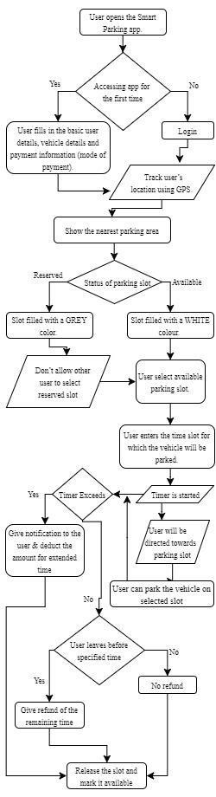

Fig 2.4 Flow chart of Smart Parking System

## [5] An IoT-Based Intelligent System for Real-Time Parking Monitoring and Automatic Billing

Today, the parking industry is being transformed by new technologies that are allowing cities to reduce rates of congestion significantly. Sensor networks that sense vehicle occupancy are providing the basic intelligence behind smart parking systems. Thanks to the Smart Parking technology, it is now possible to know in real-time the location of free parking spaces and to help drivers to get to their ultimate destination. A variety type of vehicle detectors has been used in parking information acquisition. These vehicle detectors mainly include the inductive loop , acoustic sensor , infrared sensor , or ultrasonic sensor . System using video camera sensor technologies have been proposed to collect the information in vehicle parking field. However, a video camera sensor is vulnerable to bad weather and night time operation. Furthermore, it is expensive, and can generate a large amount of data that can be difficult to transmit in a wireless network. The magneto-resistive based detection systems combined with a wireless area network are the most popular technique due to their high accuracy. Yet, this type of sensor is facing different issues, i.e. it can be bedeviled by electromagnetic interference, which affects the accuracy , the reading from sensor needs to be collected constantly which will result in wearing out the battery . To extend the battery lifetime and increase the vehicle detection accuracy, a parking sensor system has been proposed. While power management technique has been implemented to optimize energy consumption, high occupancy monitoring accuracy is achieved using two-fold sensing approach. It is a sequence of darkness and Signal Strength Indicator (RSSI) measurement based techniques. The wireless sensors are still intrusive, they are embedded in the pavement, or taped to the surface of each individual parking lot. Existing sensors, such as ground based parking sensors costs up to $200 per parking lot . As consequence, smart-parking technology using wireless sensors for outdoor parking is costly due to the large number of sensors units required to cover the entire parking lot . Although, parking occupancy monitoring systems have made a significant progress, smart parking payment is rarely studied in smart parking research . Yet, there are companies working on the patents of parking systems for payments. A first approach consists in using a camera or an RFID transceiver for vehicle detection and identification . A limitation of this solution lies in that the system is complex and its implementation is expensive when a detection device is installed on each parking lot. Furthermore, when only RFID transceiver is used for vehicle detection and identification, the system can be bedeviled by electromagnetic interference, which affects the accuracy. Moreover, this system is designed to detect a vehicle when entering a parking and seek payment, whereas information on vacant parking lots is not provided. A technique for monitoring vehicle parking using one camera to record the entrance of a vehicle and a second camera to record the vehicle leaving the parking has been proposed . Moreover, in a system and method for obtaining and displaying information on vacant parking space is described. When a user occupies a parking space designated with an individual ID, he enters this ID into a parking meter or via a smart phone mobile app., and pays the parking fees. The database processes the received data and changes the status of the parking space with its ID from unpaid to paid. These data are used as information on the occupation of a parking space. In this paper, we propose a smart sensor system allowing outdoor parking monitoring and payment without requiring any user/driver interaction. It will be deployed without having to install new components on each parking lot. The proposed sensor has benefits in terms of detection and payment reliability, and reduced expense by reducing the system complexity and installation, and extending batteries lifetime through the reduction of the system power consumption.

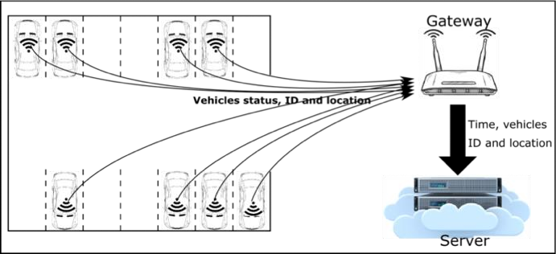

Proposed system architecture; wireless occupancy sensor; wireless gateway; data storage and processing unit.

Summary of the Approaches

|  |  |
| --- | --- |
| Approaches |  |
| It deals with saving financial cost by developing the system in the most efficient manner . | Keeps a count on number of vacant spots and prior booking. |
| Real time monitoring vehicle occupancy | Displays appropriate message |
| Android app for providing all parking | Specifying every minute |
| details to the user. | information to the user using android application . |

# SYSTEM REQUIREMENTS SPECIFICATION

## Functional Requirement

Functional Requirement defines a function of a software system and how the system must behave when presented with specific inputs/or conditions. These may include calculations, data manipulation and processing and other specific functionality. In these systems following are the functional requirements

* The application should not display in-appropriate message for valid conditions.
* The application must not stop working when kept running for even a long time.
* The application should process information for any kind of input case.
* The application should generate the output for a given input test case .

## Non-Functional Requirement

Non-functional requirements are the requirements which are not directly concerned with the specific function delivered by the system. They specify the criteria that can be used to judge the operation of a system rather than specific behaviours.

Given below are the non-functional requirements:

* Product requirements
* Organizational requirements
* Basic operational requirements

## 

## Hardware Specifications

* ENODE MCU (ESP8266)

* JUMPER WIRES

* INFRARED SENSORS

* 16*2 LED DISPLAY

* DC MOTOR

## Software Specification

• ARDUINO IDE